Secure Communication Configuration
Enhancing Security in Messaging Applications
Spinnaker Analytics
27 June 2026

Table of Contents
- Introduction
- Secure Communication Architecture
- TLS 1.3 Configuration
- Certificate Management
- Perfect Forward Secrecy Implementation
- DTLS Configuration
- Cipher Suite Configuration
- Communication Security Validation
- Security Considerations
- Standards Alignment
- Conclusion

1. Introduction

1.1 Purpose
- This document defines the secure communication controls implemented to protect data transmitted between messaging clients and backend services.
- The objective is to ensure confidentiality, integrity, authentication, and forward secrecy for all communication channels used by messaging, file transfer, authentication, and voice services.

1.2 Objectives
- Secure client-server communication
- Protect data in transit
- Enforce modern cryptographic standards
- Implement Perfect Forward Secrecy
- Prevent Man-in-the-Middle attacks
- Validate communication security through testing

2. Secure Communication Architecture
All communication channels are protected using layered security controls.

2.1 Secure Communication
Figure 21 – Secure Communication Architecture
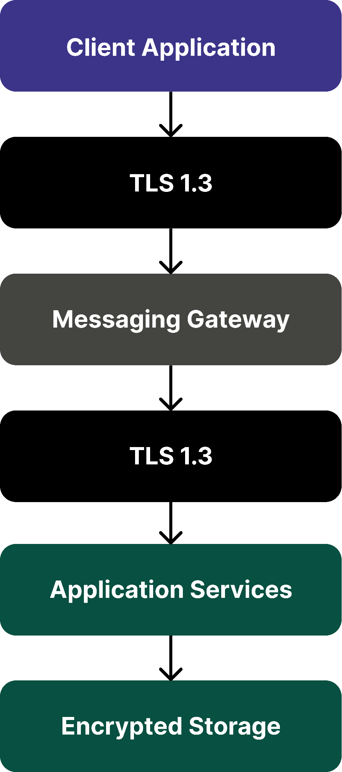

2.2 Communication Channels
Channel | Protection
Authentication | TLS 1.3
Messaging | TLS 1.3 + E2EE
File Transfer | TLS 1.3 + AES-256-GCM
Voice Signaling | TLS 1.3
Voice Media | DTLS-SRTP
API Calls | TLS 1.3

3. TLS 1.3 Configuration
TLS 1.3 provides the primary transport security mechanism.

3.1 TLS Configuration
Parameter | Configuration
Protocol Version | TLS 1.3
Legacy TLS Support | Disabled
Certificate Type | X.509
Key Exchange | ECDHE
Authentication | RSA-2048 / ECDSA
Session Resumption | Enabled

HTTP Strict Transport Security (HSTS)
Parameter | Configuration
Enabled | Yes
Max Age | 31536000
Include Subdomains | Yes

3.2 Supported Protocols
Protocol | Status
SSL 2.0 | Disabled
SSL 3.0 | Disabled
TLS 1.0 | Disabled
TLS 1.1 | Disabled
TLS 1.2 | Optional
TLS 1.3 | Enabled

3.3 TLS Handshake
Figure 22 – TLS Handshake Process

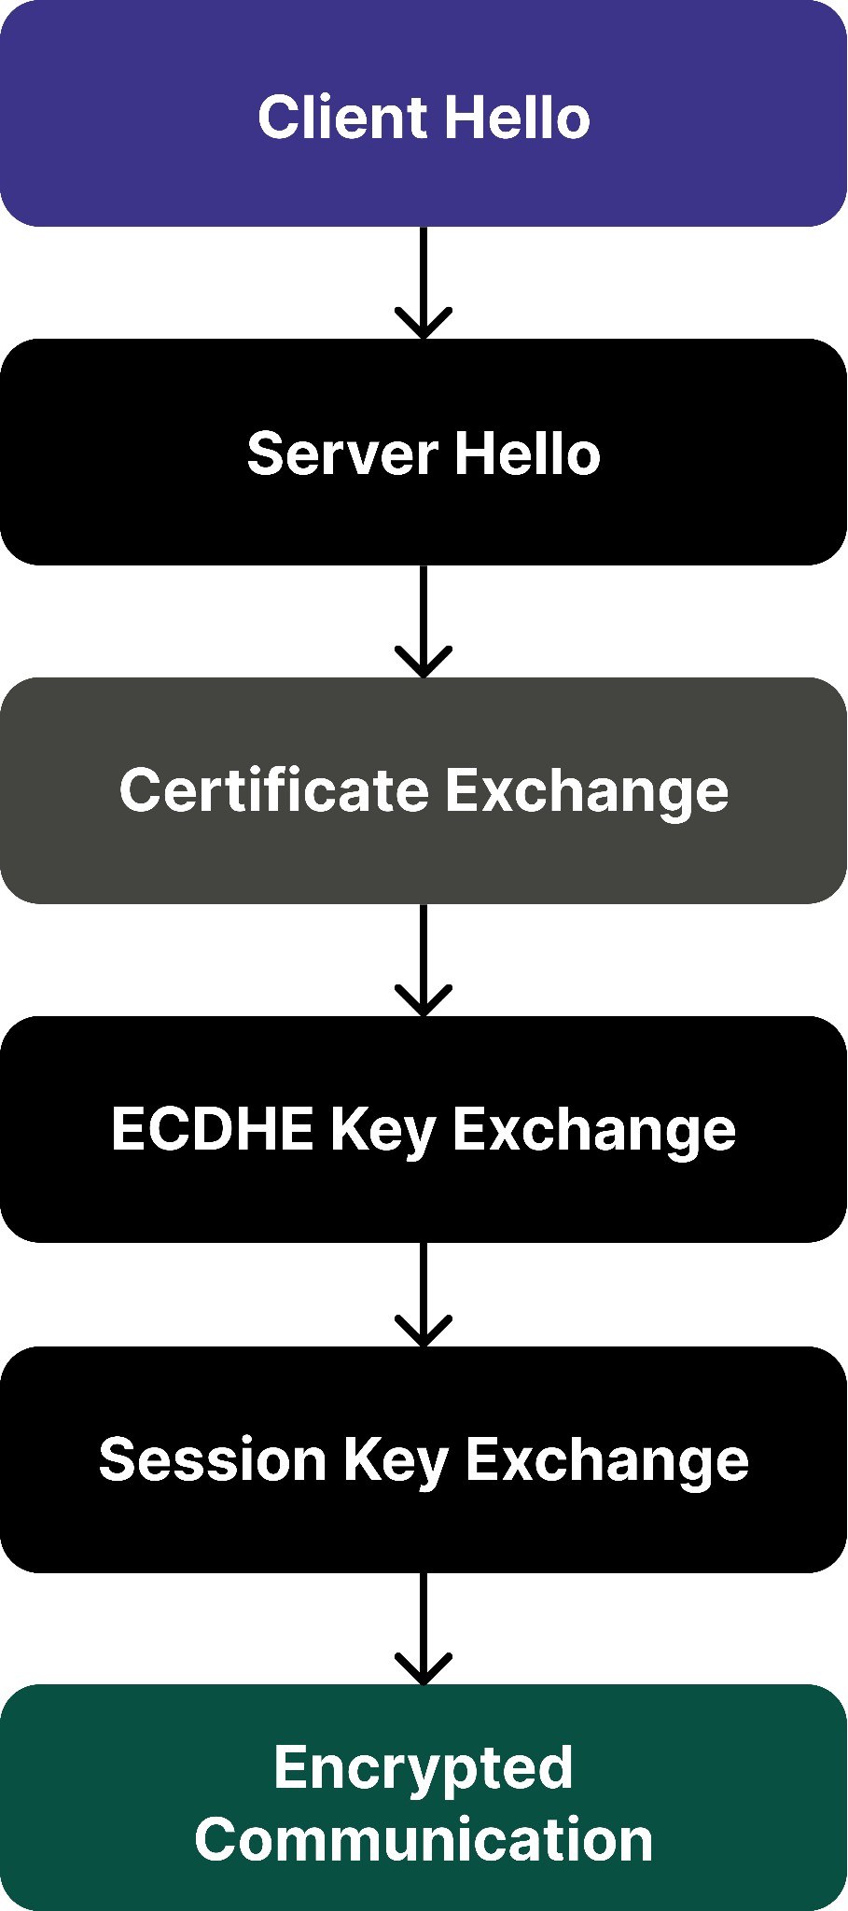

4. Certificate Management
Certificates are used to authenticate servers and establish trusted communication.

4.1 Certificate Requirements
Parameter | Value
Format | X.509
Key Size | RSA-2048 Minimum
Signature Algorithm | SHA-256
Validity Period | 365 Days
Revocation Support | CRL + OCSP

4.2 Certificate Validation Controls
- Validation Checks
  - Certificate chain validation
  - Expiration validation
  - Hostname verification
  - Revocation checking

4.3 Certificate Validation
Figure 23 – Certificate Validation Workflow
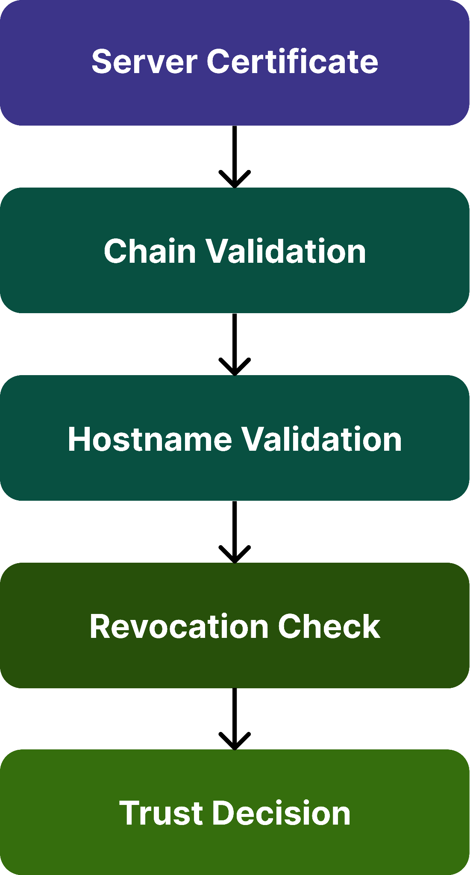

4.4 Certificate Pinning
- Certificate pinning is implemented within mobile clients to prevent acceptance of fraudulent certificates even if a trusted Certificate Authority is compromised.

Benefits
  - Protection against rogue certificates
  - Mitigation of MITM attacks
  - Enhanced trust validation
- Pinning Method
Parameter | Value
Pin Type | Public Key Pinning
Validation | SHA-256 Hash
Backup Pins | Supported

5. Perfect Forward Secrecy Implementation
Perfect Forward Secrecy ensures that historical communications remain protected even if long-term keys are compromised.

5.1 Technology Used
Technology | Purpose
ECDHE | Ephemeral Key Exchange
X3DH | Session Establishment
Double Ratchet | Message Key Rotation
DTLS | Voice Session Security

5.2 Perfect Forward Secrecy
Figure 24 – Perfect Forward Secrecy Workflow
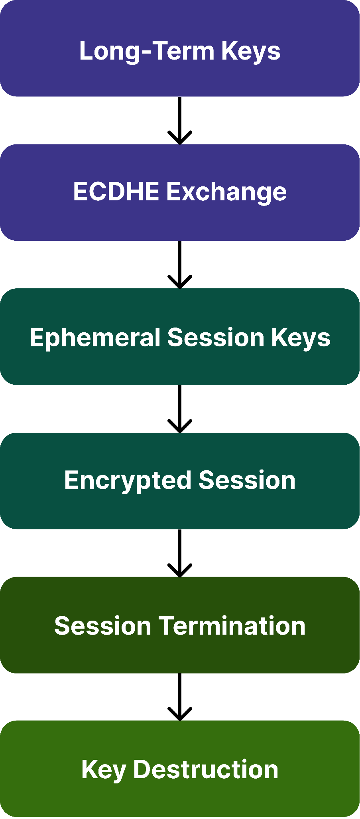

5.3 Benefits
- Historical message protection
- Session isolation
- Reduced compromise impact
- Secure key rotation

6. DTLS Configuration
- Datagram Transport Layer Security protects voice communication channels.

6.1 DTLS Settings

Parameter | Configuration
Protocol | DTLS 1.2
Key Exchange | ECDHE
Cipher | AES-128-GCM
Authentication | DTLS Certificates
PFS Support | Enabled

6.2 DTLS-SRTP Architecture
Figure 25 – DTLS-SRTP Architecture
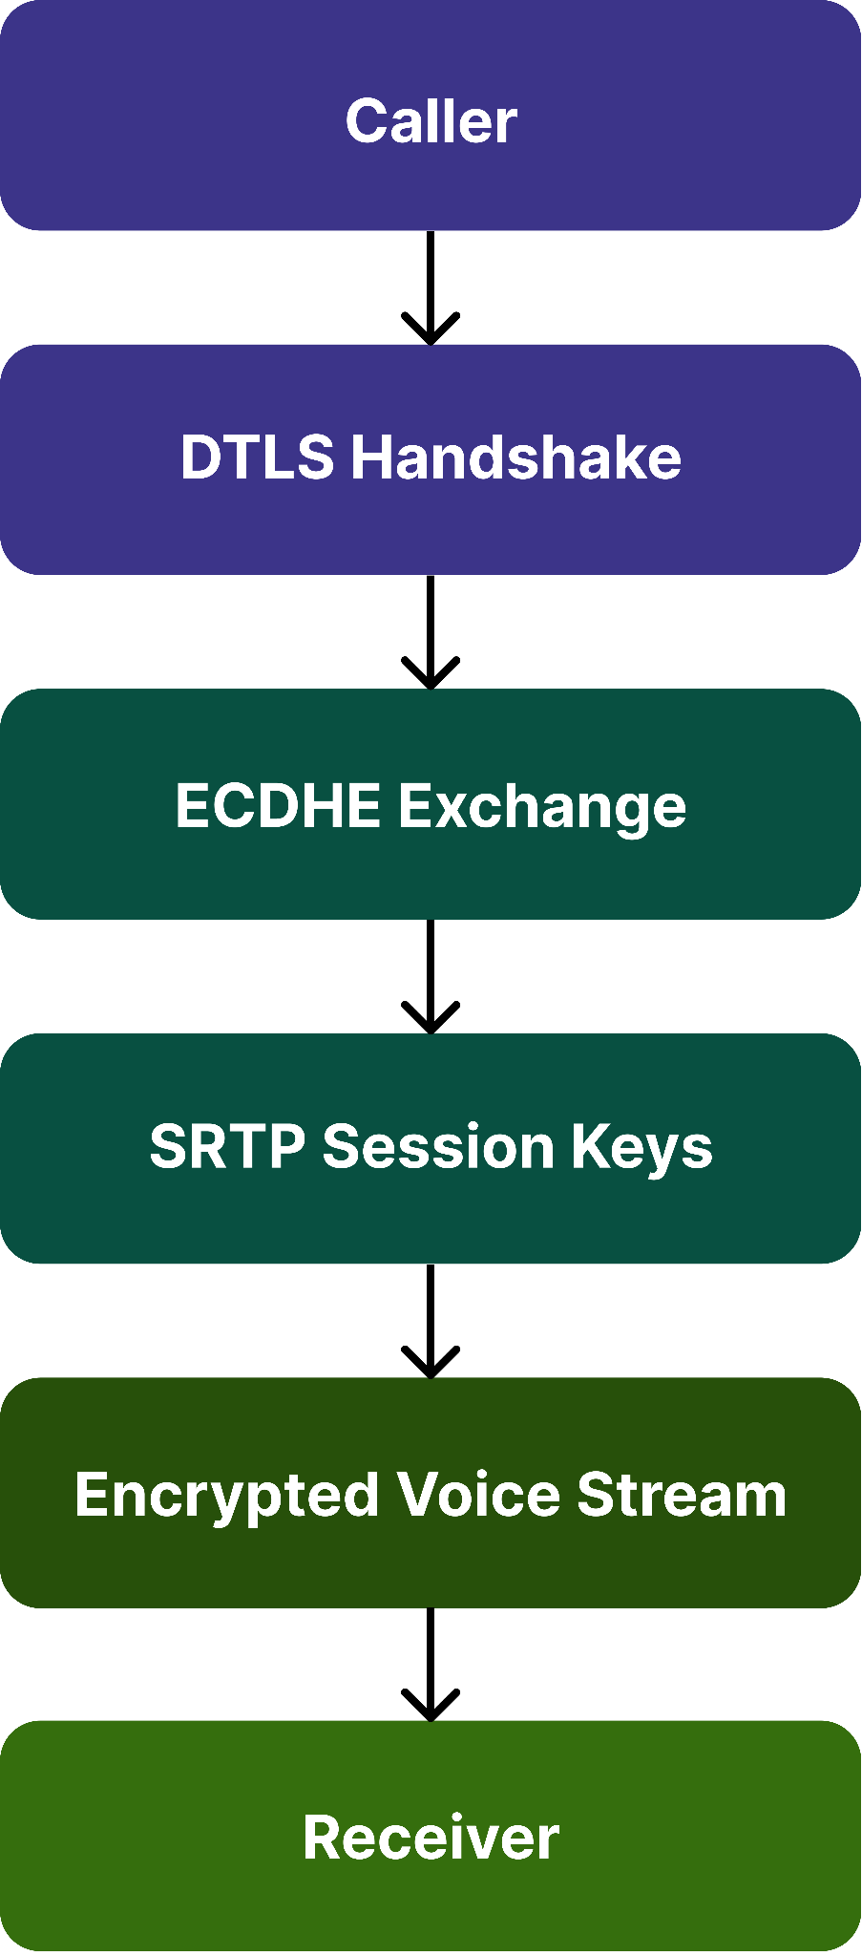

7. Cipher Suite Configuration
Only modern cryptographic suites are permitted.

7.1 Approved TLS Cipher Suites

Cipher Suite | Status
TLS_AES_256_GCM_SHA384 | Enabled
TLS_CHACHA20_POLY1305_SHA256 | Enabled
TLS_AES_128_GCM_SHA256 | Enabled

7.2 Deprecated Cipher Suites

Cipher Suite | Status
RC4 | Disabled
DES | Disabled
3DES | Disabled
MD5-Based Suites | Disabled

7.3 Security Controls
- Strong encryption only
- Authenticated encryption
- Forward secrecy support
- Secure key exchange

8. Communication Security Validation
Communication controls must be validated through testing.

8.1 Testing Environment
Tool | Purpose
Wireshark | Packet Analysis
Burp Suite Community | TLS Verification
OpenSSL | Certificate Testing
SSL Labs | TLS Assessment

Figure 26 – Validation Process
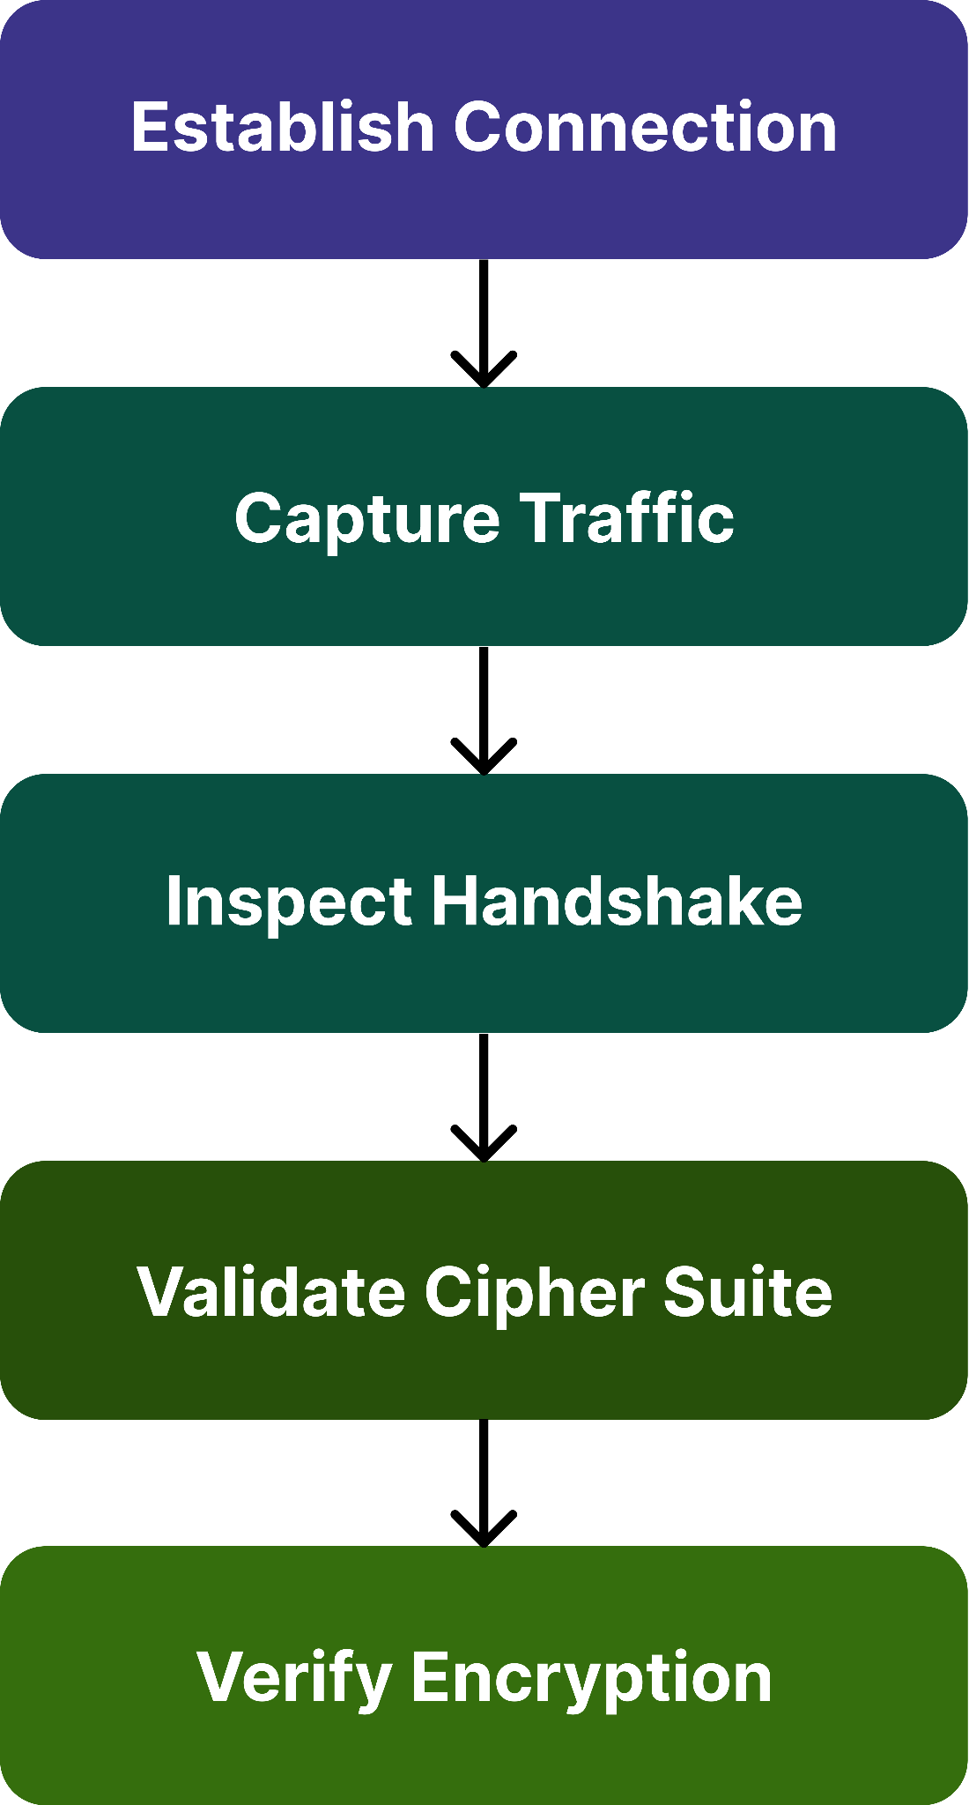

8.2 Validation Objectives
- TLS Validation
  - Verify:
    - TLS 1.3 active
    - Certificate validation
    - Secure cipher suites
- DTLS Validation
  - Verify:
    - DTLS handshake
    - SRTP key generation
    - Encrypted voice traffic

8.3 Test Cases
Test ID | Test Scenario | Expected Result
COMM-01 | TLS Connection | TLS 1.3 Established
COMM-02 | Certificate Validation | Trusted Certificate
COMM-03 | Cipher Inspection | Approved Cipher
COMM-04 | DTLS Handshake | Successful
COMM-05 | Voice Session | SRTP Active
COMM-06 | MITM Simulation | Connection Blocked

8.4 Expected Evidence
- Wireshark captures
- TLS handshake screenshots
- OpenSSL verification results
- SSL Labs assessment report

Validation Area | Expected Outcome
TLS Version | TLS 1.3
Certificate Chain | Trusted
Cipher Suite | Approved
PFS | Verified
DTLS Session | Successful
SRTP Traffic | Encrypted

9. Security Considerations

9.1 Threats & Mitigations
Threat | Mitigation
MITM Attacks | TLS 1.3
Certificate Spoofing | Certificate Validation
Weak Cipher Attacks | Approved Cipher Suites
Session Hijacking | ECDHE
Replay Attacks | Nonces
Downgrade Attacks | TLS 1.3 Enforcement

10. Standards Alignment
Standard | Purpose
RFC 8446 | TLS 1.3
RFC 6347 | DTLS
RFC 5246 | TLS Framework
RFC 5280 | X.509 Certificates
NIST SP 800-52 | TLS Guidance
OWASP MASVS | Mobile Security

11. Conclusion
- This Secure Communication Configuration document defines the controls used to secure all communication channels within the messaging application.
  - The architecture combines:
    - TLS 1.3 transport security
    - DTLS-secured voice communication
    - Strong certificate management
    - Modern cipher suites
    - Perfect Forward Secrecy
    - Comprehensive communication validation
- These controls ensure secure transmission of messages, files, authentication data, and voice communications while protecting against interception, spoofing, downgrade attacks, and unauthorized access.

